Traditional Language models

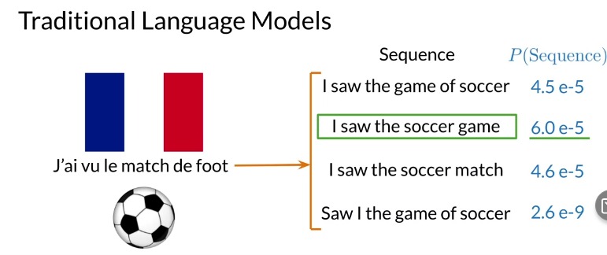
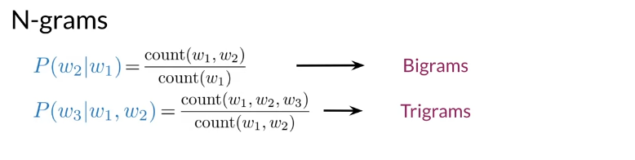

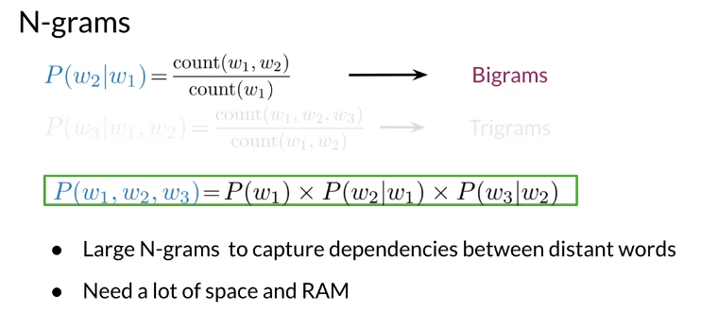
Large N-grams capture dependencies between distant words and need a lot of space and RAM. Hence, we resort to using different types of alternatives.

Recurrent Neural Networks

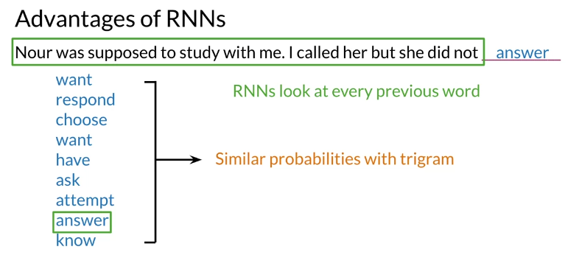
Previously, we tried using traditional language models, but it turns out they took a lot of space and RAM. For example, in the sentence below:

An N-gram (trigram) would only look at "did not" and would try to complete the sentence from there. As a result, the model will not be able to see the beginning of the sentence "I called her but she". Probably the most likely word is have after "did not". RNNs help us solve this problem by being able to track dependencies that are much further apart from each other. As the RNN makes its way through a text corpus, it picks up some information as follows:

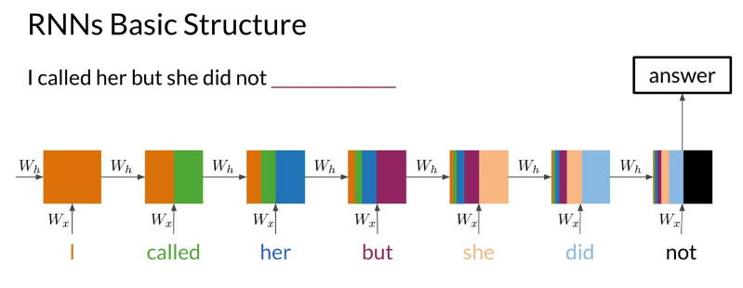
Note that as you feed in more information into the model, the previous word's retention gets weaker, but it is still there. Look at the orange rectangle above and see how it becomes smaller as you make your way through the text. This shows that your model is capable of capturing dependencies and remembers a previous word although it is at the beginning of a sentence or paragraph. Another advantage of RNNs is that a lot of the computation shares parameters.

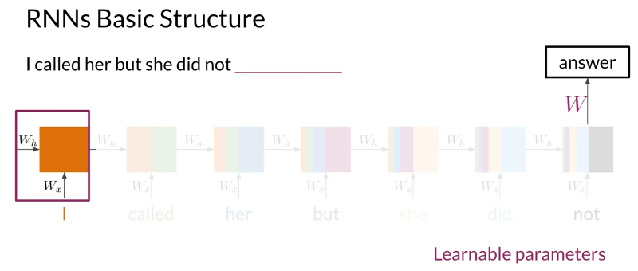

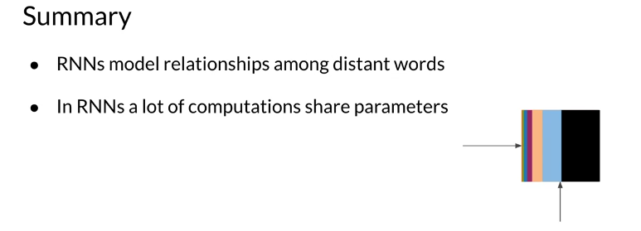

Applications of RNNs

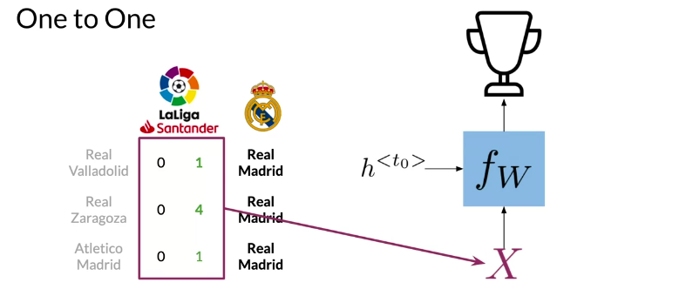

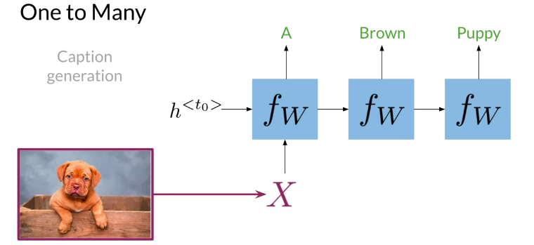

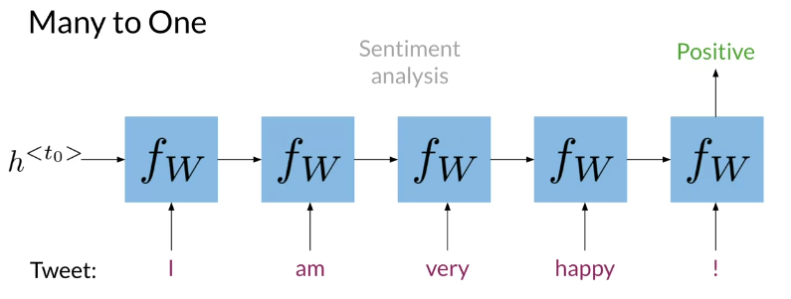
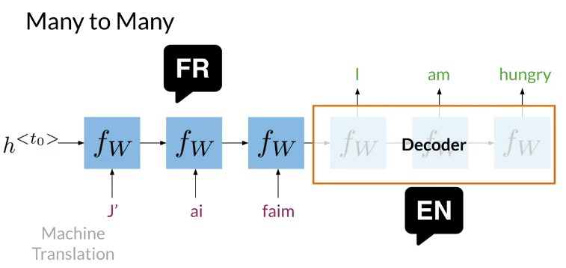

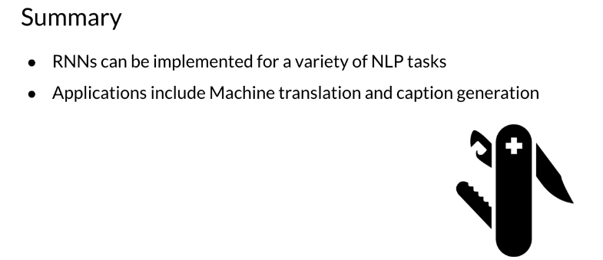

RNNs could be used in a variety of tasks ranging from machine translation to caption generation. There are many ways to implement an RNN model:
- One to One: given some scores of a championship, you can predict the winner.
- One to Many: given an image, you can predict what the caption is going to be.
- Many to One: given a tweet, you can predict the sentiment of that tweet.
- Many to Many: given an english sentence, you can translate it to its German equivalent.
In the next video, you will see the math in simple RNNs.

Math in Simple RNNs

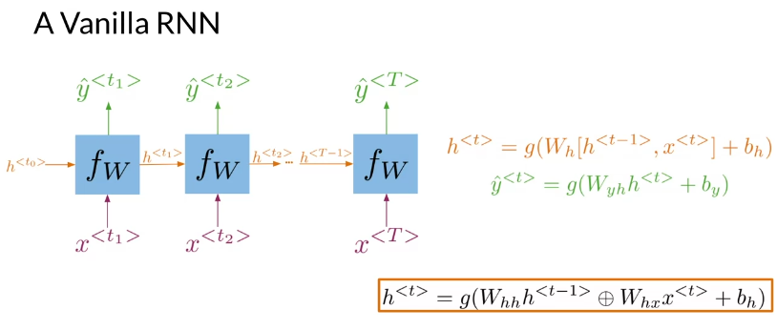
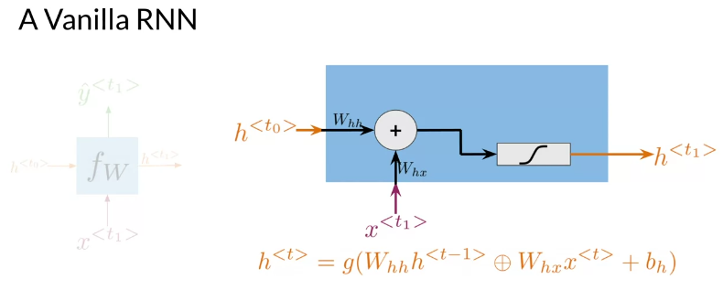
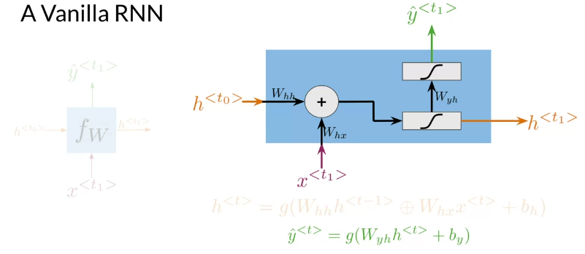

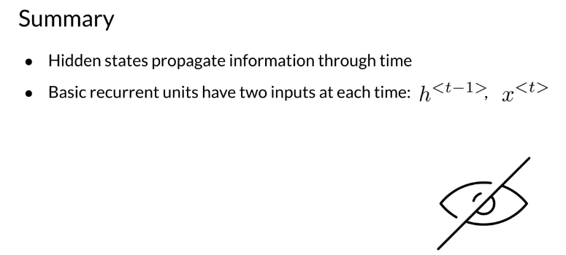

Cost Function for RNNs
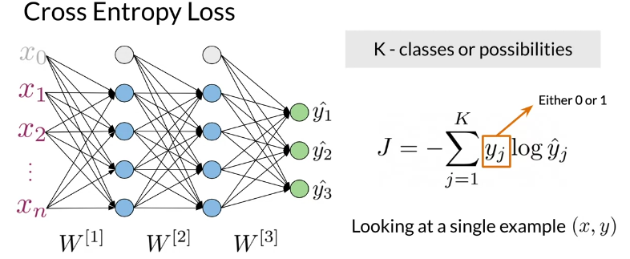

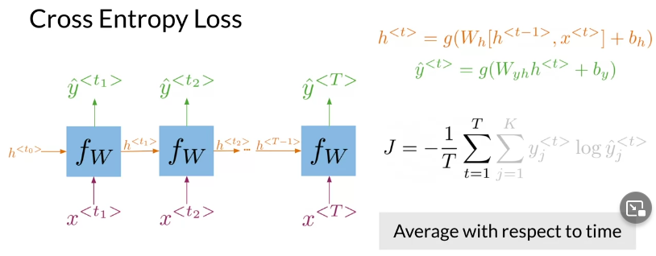
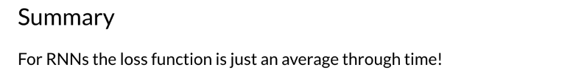

Implementation Note

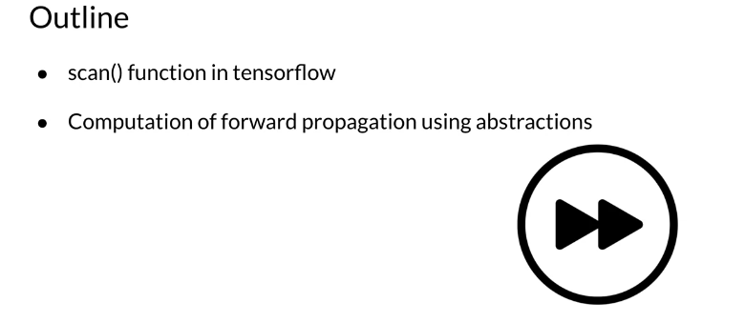

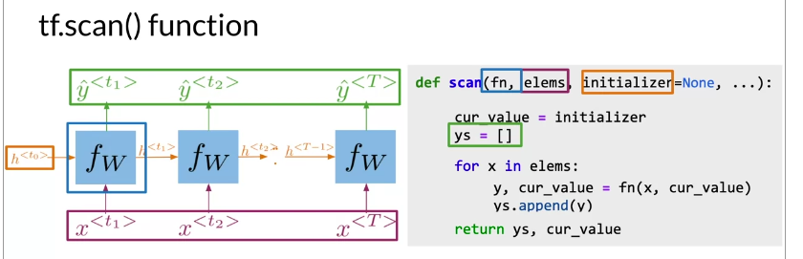
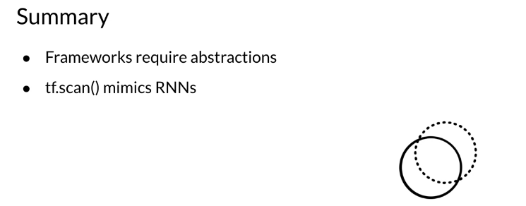

Gated Recurrent Units

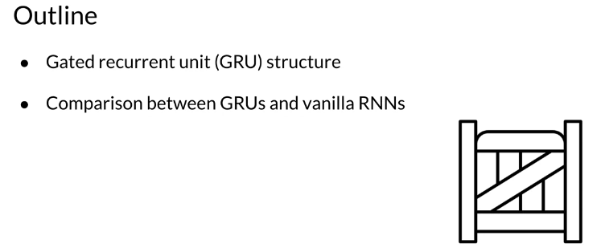

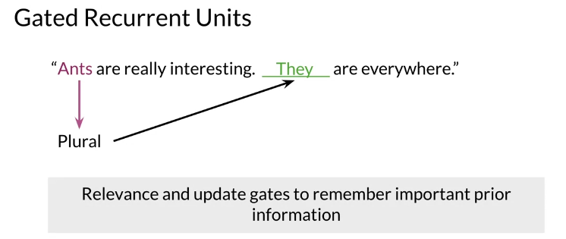
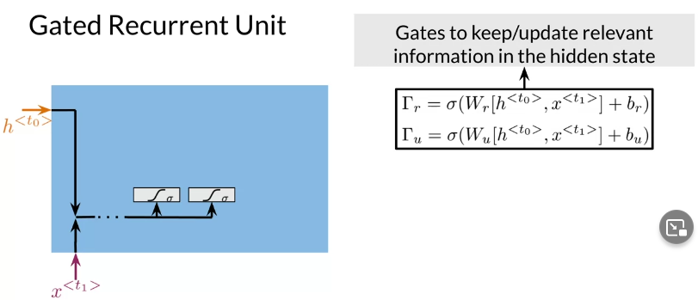

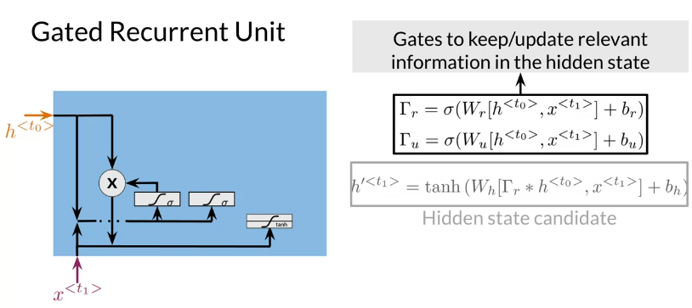

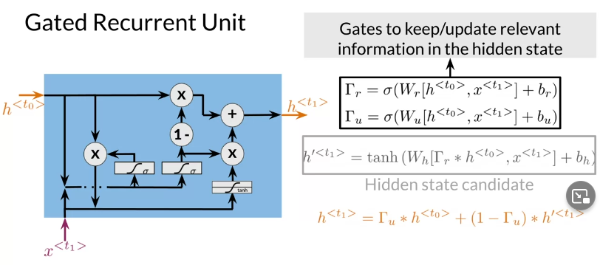

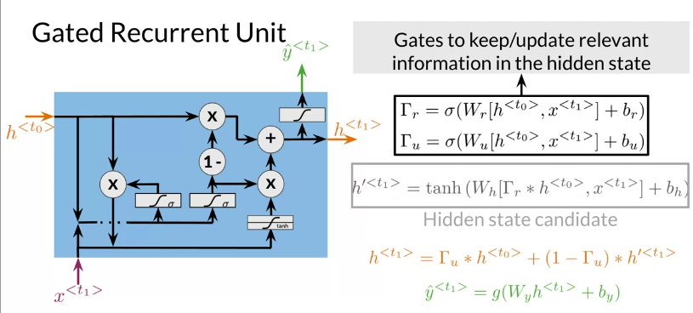

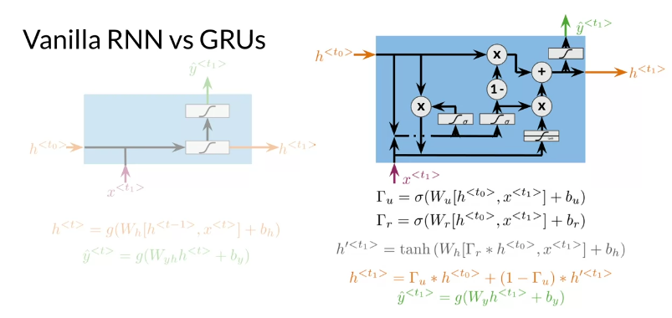

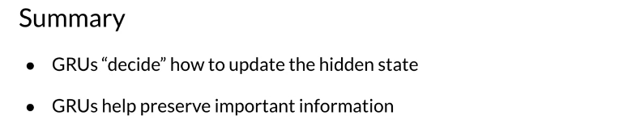

Deep and Bi-directional RNNs

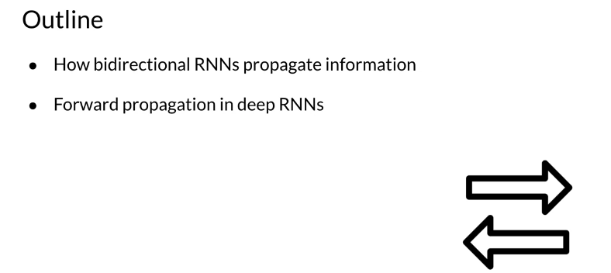
Bi-directional RNNs are important, because knowing what is next in the sentence could give you more context about the sentence itself.

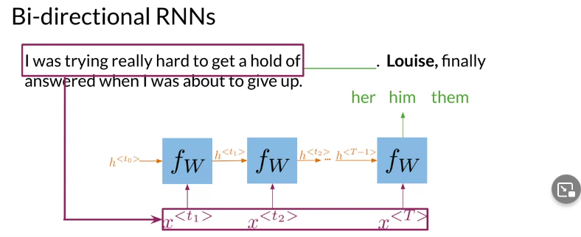
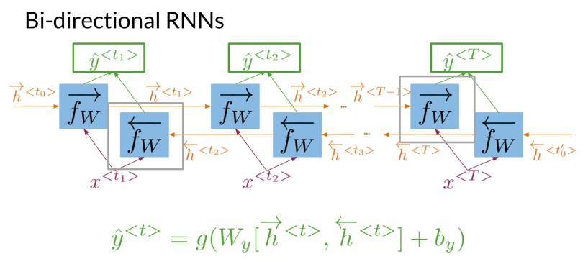
So you can see, in order to make a prediction y^​, you will use the hidden states from both directions
and combine them to make one hidden state, you can then proceed as you would with a simple vanilla RNN. When implementing Deep RNNs, you would compute the following.
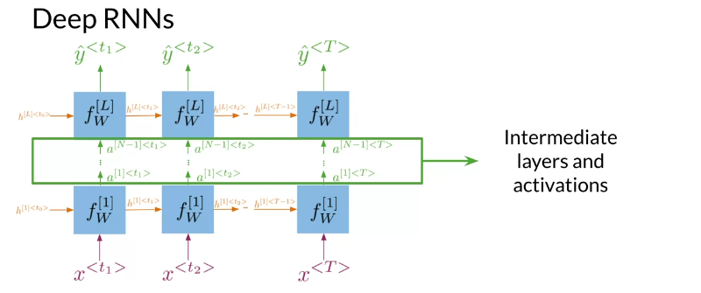

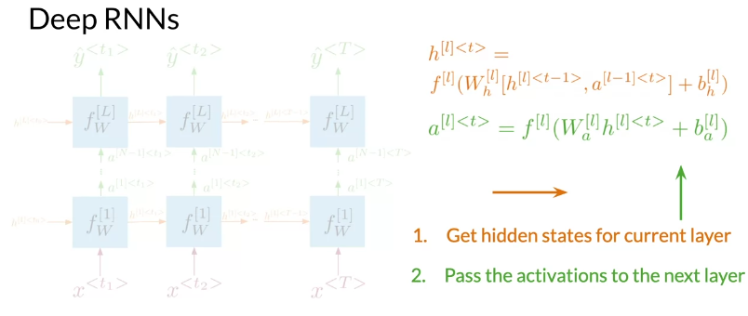
Note that at layer l, you are using the input from the bottom a[l−1] and the hidden state hl. That allows you to get your new h, and then to get your new a, you will train another weight matrix Wa​, which you will multiply by the corresponding h add the bias and then run it through an activation layer.

